# General

Communication from a Digital Command Station to a Digital Decoder is accomplished by transmitting a series of bits that convey instructions. A bit is a signal which represents one of two conditions, which we will call "1" and "0". This portion of the standard covers the electrical characteristics of the digital command control signal that encodes these bits.

Please refer to Tables 2.1, 2.2 and 2.3 for definition and numerical values of parameters used throughout this document.

## Introduction and Intended Use (Informative)

## References

This standard should be interpreted in the context of the following NMRA Standards, Technical Notes, and Technical Information.

### Normative

* S-9
* S-9.2

### Informative

* None

## Terminology

|  |  |
| --- | --- |
| **Term** | **Definition** |
| Vehicle | Mobile model railroad device. This includes locomotives and other rolling stock. |
| Decoder (mobile) | DCC receiver for controlling vehicle animation. |
| Accessory Decoder | DCC receiver for controlling accessories. |
| Accessories | Fixed model railroad device. This includes turnouts, lights, signals and other devices not on the rails. |
| Power Station | A device that amplifies the low current DCC electrical signals transmitted by a Command Station for the purpose of providing high current DCC signals with sufficient power to operate model trains and any accessory decoders that are connected to the track. The power station may be a separate device or may be combined with the command station and/or throttle. Sometimes referred to as a booster. |

# Technique for Encoding Bits

The NMRA baseline digital command control signal consists of a stream of transitions between two equal voltage levels that have opposite polarity[1]. Alternate transitions separate one bit from the next. The remaining transitions divide each bit into a first part and a last part. Digital Command Stations shall encode bits within this digital command control stream of transitions by varying the duration of the parts of the bits, or frequency of the transitions.

In a “1” bit, the first and last part of a bit shall have the same nominal duration, and that duration shall be **t1**[2], giving the bit a nominal total duration of **(2x t1)**. Digital Command Station components shall transmit “1” bits with the first and last parts each having a duration within the **t1** range. The duration difference between the first and last parts of a “1” bit shall not exceed **t1d**.

A Digital Decoder must accept bits whose first and last parts have a duration within the **tr1** range as a valid bit with the value of “1”. Digital Decoders must accept “1” bits where the duration difference between the positive and negative components does not exceed **tr1d**.

In a “0” bit, the duration of the first and last parts of each transition shall nominally be greater than or equal to **t0**. To keep the DC component of the total signal at zero as with the “1” bits, the first and last part of the “0” bit are normally of equal duration. Digital Command Station components shall transmit “0” bits with each part of the bit having a duration within the **t0** range with the total bit duration of the “0” bit not exceeding **t0tot**. A Digital Decoder must accept bits, whose first or last parts have a duration within the **tr0** range as a valid bit with the value of “0”. Figure 2.1 provides an example of bits encoded using this technique.

**Figure 2.1: Bit Encoding**

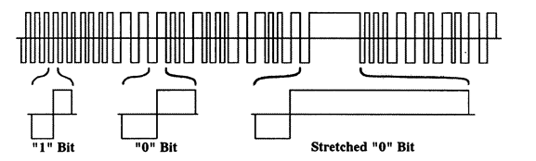

This is a differential signal with no ground. At the point where the signal line crosses the horizontal reference line, both rails will be at the same voltage.

## One Bit Timing

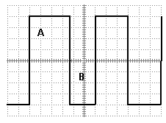

|  |  |
| --- | --- |
| For Power **Station** Output under Load: |  |
|  |  |
| Relationship for One Bits | Result |
| Period A < ***( t1min.)*** or Period A > ***( t1max.)*** | Bad |
| Period A = Period B | OK |
| |Period A – Period B| <= ***( t1dmax.)*** | OK |
| |Period A – Period B| > ***(t1dmax.)*** | Bad |
|  |  |
| **Decoders** must accept: |  |
|  |  |
| Relationship for One Bits | Result |
| Period A >= ***(tr1min.)*** & Period A <= ***(tr1max)*** | OK |
| Period A = Period B | OK |
| |Period A – Period B| <= ***( tr1d_max.)*** | OK |
|  |  |

|  |  |  |  |  |  |  |
| --- | --- | --- | --- | --- | --- | --- |
| ***Table 2.1 – DCC Bit Timing*** | | | | | | |
| **Parameter** | **Definition** | **Value** | | | **Unit** | **Comments** |
|  |  | Min. | Nominal | Max. |  |  |
| t1 | “1” Half Bit duration | 55 | 58 | 61 | µSec | Duration of a transmitted “1” half bit |
| tr1 | “1” Half Bit received duration | 52 | 58 | 64 | µSec | Allowed Duration for a received “1” half bit |
| t0 | “0” Half Bit duration | 95 | 100 | 9900 | µSec | Duration of a transmitted “0” half bit |
| t0total | stretched “0” Bit duration |  |  | 12000 | µSec | Max. total duration of stretched “0” bit |
| tr0 | “0” Half Bit received duration | 90 | 100 | 10000 | µSec | Allowed Duration for a received “0” half bit |
| t1d | “1” half bit duration delta |  |  | 3 | µSec | Max. difference in duration between transmitted “1”bit half bits. |
| Tr1d | Received “1” half bit duration delta |  |  | 6 | µSec | Max. difference in duration between received “1” bit half bits. |

## Command Control Signal Shape

The NMRA digital signal applied to the track by any Digital Command Control system, as measured at the power station output, shall have the following characteristics, as measured under conditions ranging from no load to the maximum continuous load permitted by the power source. Transitions that cross the region between **VtrL** and **VtrH**[3] shall occur at the rate of **VtrA** or faster. This signal may contain non-monotonic distortion at the zero-crossing transitions, provided that this distortion shall have an amplitude of no greater than +/- **Vdist**[4].

Digital Decoders shall be designed to correctly decode signals with transitions whose slope is **VtrRA** or faster across the voltage range from **VtrL** to **VtrH**. A Digital Decoder shall correctly decode properly addressed baseline packets at a probability of **Pdecode** or higher, as defined in S-9.2, in the presence of noise (and/or other types of signals) at frequencies above **FNoise** with a total peak-to-peak amplitude of less than (**1/ Vsnr**) of the peak-to-peak amplitude of the NMRA digital signal[5].

|  |  |  |  |  |  |  |
| --- | --- | --- | --- | --- | --- | --- |
| ***Table 2.2 DCC Signal parameters Shape/ Amplitude*** | | | | | | |
| **Parameter** | **Definition** | **Value** | | | **Unit** | **Comments** |
|  |  | Min. | Nominal | Max. |  |  |
| VtrL | Transition region Vmin. |  | -4 |  | Volt | Low limit of bit transition region |
| VtrH | Transition region Vmax. |  | 4 |  | Volt | High limit of bit transition region |
| VtrA | Transition rate | 2.5 |  |  | Volt/µSec | Transmitted bit voltage transition rate |
| Vdist | Distortion Amplitude |  |  | 2 | Volt | Distortion voltage during bit transition |
| VtrRA | Receive transition rate | 2 |  |  | Volt/µSec | Received bit voltage Transition rate |
| Pdecode | Decode probability | 0.95 |  |  |  | Percentage of packets decoded correctly |
| FNoise | Noise frequency | 100 |  |  | KHz | Frequency of noise or other signal |
| Vsnr | Peak Signal to Noise Amplitude Ratio | 4 |  |  |  | Peak DCC signal to peak FNoise |

## Power Transmission and Voltage Limits for Transmitting Power through the Rails

The baseline method for providing the power to operate locomotives and accessories, which shall be supported by all Digital Command Stations and Digital Decoders, is by full-wave rectification of the bipolar NMRA digital signal within the Digital Decoder[6]. In order to maintain power to the Digital Decoders, gaps in bit transmission are only allowed at specified times (see S-9.2, Section C).

The peak value of NMRA digital signal, as produced by the power station and measured at the track, shall be confined to the range of **VDCCp** for the applicable scale, as specified in Table 2.3[7]. In no case should the peak amplitude of the command control signal exceed **VDCCp_max** for the applicable scale.

Digital Decoders shall be designed to continuously operate and withstand, without permanent damage to the decoder; a peak maximum voltage within the range of **VDCCr** as specified in Table 2.3 for the applicable scale, measured at the track.

|  |  |  |  |  |  |  |
| --- | --- | --- | --- | --- | --- | --- |
| ***Table 2.3 – Power transmission and amplitude limit parameters*** | | | | | | |
| **Parameter** | **Definition** | **Value** | | | **Unit** | **Comments** |
|  |  | Min. | Nominal | Max. |  |  |
| VDCCp –  N and smaller Scales | Voltage limits for track, N and smaller scales for power station | 8.5 | 12 | 22 | Volt | Voltage produced powering the track |
| VDCCp –  HO/S/O Scales | Voltage limits for track HO/S/O scales for power station | 8.5 | 15 | 22 | Volt | Voltage produced powering the track |
| VDCCp –  Large Scales | Voltage limits for track, large scales for power station | 8.5 | 18 | 24 | Volt | Voltage produced powering the track |
| VDCCr –  N and smaller Scales | Voltage limits for track, N and smaller scales for digital decoders | 7 | 12 | 24 | Volt | Peak voltage decoder should operate in and withstand |
| VDCCr –  HO/S/O Scales | Voltage limits for track HO/S/O scales for digital decoders | 7 | 15 | 27 | Volt | Peak voltage decoder should operate in and withstand |
| VDCCr –  Large Scales | Voltage limits for track, large scales for digital decoders | 7 | 18 | 27 | Volt | Peak voltage decoder should operate in and withstand |

Digital Decoders shall be designed to interpret a valid packet addressed to it whilst supplied a minimum voltage **VDDCr** as specified in Table 2.3 and to acknowledge the receipt of a command in that packet by some action E.G. turning on a low power output to illuminate an LED. The Digital Decoder is not required to turn the motor at this voltage. This an an indication of the Digital Decoder’s ability to read instructions addressed to it at the specified minimum voltage at the track.

**Minimum Voltage for Power Station** **Maximum Voltage for Power Station**

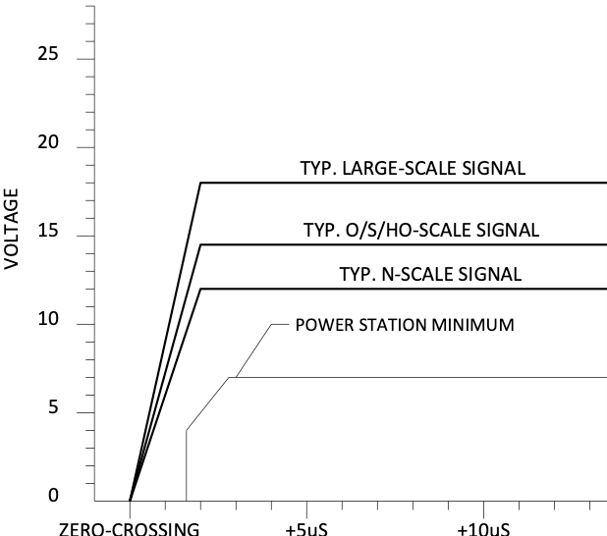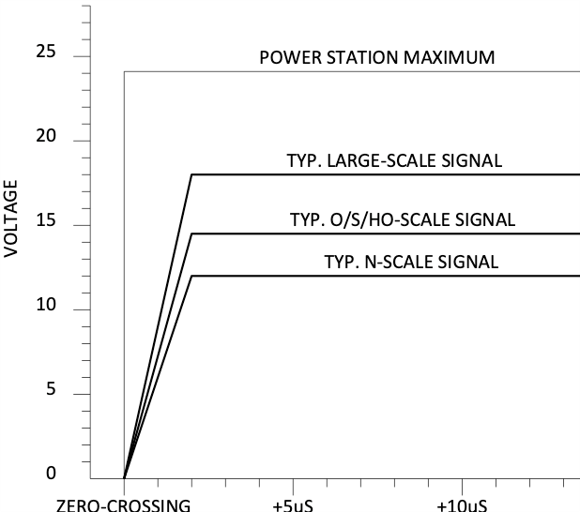

**Minimum Voltage for Decoders Maximum Voltage for Decoders**

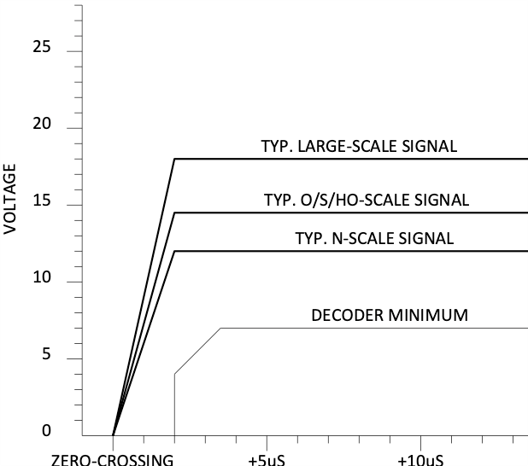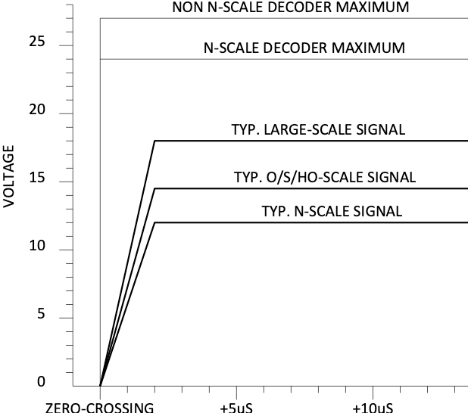

# Document History

|  |  |
| --- | --- |
| **Date** | **Description** |
| Jan 2019 | Tabularized data, removing it from the text and replacing with a variable to make future revisions less prone to missing changes in the text. Cleaned up grammar and language. |
| Feb 2019 | Table 3 increased large scale power station maximum voltage large to 24v from 22v. |
| Jan 21, 2021 | Updated Graphs on Last Page to reflect higher max voltage on large scale. Removed requirement for FCC & CE certification to meet NMRA Standard. |

**Important Notices and Disclaimers Concerning NMRA Standards Documents**

The Standards (S), Recommended Practices (RP), Technical Note (TN), and Technical Information (TI) documents of the National Model Railroad Association (“NMRA Standards documents”) are made available for use subject to important notices and legal disclaimers. These notices and disclaimers, or a reference to this page, appear in all standards and may be found under the heading "Important Notices and Disclaimers Concerning NMRA Standards Documents."

**Notice and Disclaimer of Liability Concerning the Use of NMRA Standards Documents**

NMRA Standards documents are developed within the Standards and Conformance Department of the NMRA in association with certain Working Groups, members, and representatives of manufacturers and sellers. NMRA develops its standards through a consensus development process, which brings together volunteers representing varied viewpoints and interests to achieve the final product. NMRA Standards documents are developed by volunteers with modeling, railroading, engineering, and industry-based expertise. Volunteers are not necessarily members of NMRA, and participate without compensation from NMRA.

NMRA does not warrant or represent the accuracy or completeness of the material contained in NMRA Standards documents, and expressly disclaims all warranties (express, implied and statutory) not included in this or any other document relating to the standard or recommended practice, including, but not limited to, the warranties of: merchantability; fitness for a particular purpose; non-infringement; and quality, accuracy, effectiveness, currency, or completeness of material. In addition, NMRA disclaims any and all conditions relating to results and workmanlike effort. In addition, NMRA does not warrant or represent that the use of the material contained in NMRA Standards documents is free from patent infringement. NMRA Standards documents are supplied “AS IS” and “WITH ALL FAULTS.”

Use of NMRA Standards documents is wholly voluntary. The existence of an NMRA Standard or Recommended Practice does not imply that there are no other ways to produce, test, measure, purchase, market, or provide other goods and services related to the scope of the NMRA Standards documents. Furthermore, the viewpoint expressed at the time that NMRA approves or issues a Standard or Recommended Practice is subject to change brought about through developments in the state of the art and comments received from users of NMRA Standards documents.

In publishing and making its standards available, NMRA is not suggesting or rendering professional or other services for, or on behalf of, any person or entity, nor is NMRA undertaking to perform any duty owed by any other person or entity to another. Any person utilizing any NMRA Standards document, should rely upon their own independent judgment in the exercise of reasonable care in any given circumstances or, as appropriate, seek the advice of a competent professional in determining the appropriateness of a given NMRA Standards documents.

IN NO EVENT SHALL NMRA BE LIABLE FOR ANY DIRECT, INDIRECT, INCIDENTAL, SPECIAL, EXEMPLARY, OR CONSEQUENTIAL DAMAGES (INCLUDING, BUT NOT LIMITED TO: THE NEED TO PROCURE SUBSTITUTE GOODS OR SERVICES; LOSS OF USE, DATA, OR PROFITS; OR BUSINESS INTERRUPTION) HOWEVER CAUSED AND ON ANY THEORY OF LIABILITY, WHETHER IN CONTRACT, STRICT LIABILITY, OR TORT (INCLUDING NEGLIGENCE OR OTHERWISE) ARISING IN ANY WAY OUT OF THE PUBLICATION, USE OF, OR RELIANCE UPON ANY STANDARD OR RECOMMENDED PRACTICE, EVEN IF ADVISED OF THE POSSIBILITY OF SUCH DAMAGE AND REGARDLESS OF WHETHER SUCH DAMAGE WAS FORESEEABLE.

**Translations**

NMRA’s development of NMRA Standards documents involves the review of documents in English only. In the event that an NMRA Standards document is translated, only the English version published by NMRA is the approved NMRA Standards document.

**Official Statements**

A statement, written or oral, that is not processed in accordance with NMRA policies for distribution of NMRA communications, or approved by the Board of Directors, an officer or committee chairperson, shall not be considered or inferred to be the official position of NMRA or any of its committees and shall not be considered to be, nor be relied upon as, a formal position of NMRA.

**Comments on Standards**

Comments for revision of NMRA Standards documents are welcome from any interested party, regardless of membership. However, **NMRA does not provide interpretations, consulting information, or advice pertaining to NMRA Standards documents.**

Suggestions for changes in documents should be in the form of a proposed change of text, together with appropriate supporting comments. Since NMRA standards represent a consensus of concerned interests, it is important that any responses to comments and questions also receive the concurrence of a balance of interests. For this reason, NMRA, its departments, Working Groups or committees cannot provide an instant response to comments, or questions except in those cases where the matter has previously been addressed. For the same reason, NMRA does not respond to interpretation requests. Any person who would like to participate in evaluating comments or in revisions to NMRA Standards documents may request participation in the relevant NMRA working group.

**Laws & Regulations**

Users of NMRA Standards documents should consult all applicable laws and regulations. Compliance with the provisions of any NMRA Standards document does not constitute compliance to any applicable regulatory requirements. Implementers of the standard are responsible for observing or referring to the applicable regulatory requirements. NMRA does not, by the publication of NMRA Standards documents, intend to urge action that is not in compliance with applicable laws, and NMRA Standards documents may not be construed as doing so.

**Copyrights**

NMRA Standards documents are copyrighted by NMRA under US and international copyright laws. They are made available by NMRA and are adopted for a wide variety of both public and private uses. These include both use, by reference, in laws and regulations, and use in private self-regulation, standardization, and the promotion of modeling, structural and engineering practices and methods. By making NMRA Standards documents available for use and adoption by public authorities and private users, NMRA does not waive any rights in copyright to the NMRA Standards documents.

**IMPORTANT NOTICE**

NMRA Standards documents do not guarantee or ensure safety, security, health, or environmental protection, or ensure against interference with or from other systems, devices or networks. NMRA Standards documents development activities consider research and information presented to the standards development group in developing any safety recommendations. Other information about safety practices, changes in technology or technology implementation, or impact by peripheral systems also may be pertinent to safety considerations during implementation of the standard. Implementers and users of NMRA Standards documents are responsible for determining and complying with all appropriate safety, security, environmental, health, and interference protection practices and all applicable laws and regulations.

1. Note that since a locomotive or piece of rolling stock can be placed upon a given section of track facing in either direction, it is impossible to define, from the point of view of a Digital Decoder, whether the first or last part of a bit will have the "positive" voltage polarity.
2. All timing measurements are done between zero-volt crossings.
3. 0 volts is the midpoint of the differential voltage.
4. This standard specifically permits super-imposing non-NMRA signals upon the rails for other purposes, provided that the NMRA Digital Decoder can reject these signals.
5. This measurement is made with the Digital Decoder electrically connected to a track or accessory bus.
6. Alternate means for supplying power are acceptable, provided that Digital Command Station power units are capable of producing the baseline track signal, and Digital Decoders are capable of operation from the baseline track signal as described by this standard.
7. Care should be taken to ensure that any motors exposed directly to the digital signal for extended periods have a stall rating that exceeds the amplitude of the signal, or sufficiently high impedance at 4-9 kHz to reduce the current to normal operating level. This appears to only be a concern for high-precision core-less can motors, which present a low impedance load, or for layouts using an NMRA digital signal with an amplitude in excess of ± 18 volts.